**Replication of Results of the Dadkhahi, Gotchev, and Egiazarian Inverse Polynomial Reconstruction Method (IPRM) in the DCT Domain**



Alex Reigle

CEG 7850 Digital Image Processing

Wright State University

Instructor: Dr. Arnab Shaw

December 8, 2021

**Table of Contents**

Declaration Statement …………………………………………………………………………………………………………... 3

Abstract …………………………………………………………………………………………………………………………………. 4

Introduction …………………………………………………………………………………………………………………………… 5

Technical Discussion ………………………………………………………………………………………………………………. 6

Results …………………………………………………………………………………………………………………………………… 7

Discussion of Results …………………………………………………………………………………………………………..… 24

Discussion ………………..…………………………………………………………………………………………………………… 27

References ……..……………………………………………………………………………………………………………………… 28

Figures ………………….……………………………………………………………………………………………………………….. 29

Appendix ……………………………………………………………………………………………………………………………….. 47

**Declaration Statement**

I hereby declare that this Report and the Matlab codes were written/prepared entirely by me based on my own work, and I have not used any material from another Project at another department/ university/college anywhere else, including Wright State. I also declare that I did not seek or receive assistance from any other person and I did not help any other person to prepare their reports or code.  The report mentions explicitly all sources of information in the reference list. I am aware of the fact that violation of these clauses is regarded as cheating and can result in invalidation of the paper with zero grade. Cheating or attempted cheating or assistance in cheating is reportable to the appropriate authority and may result in the expulsion of the student, in accordance with the University and College Policies.

**1 Abstract**

A partial replication of results of the “Inverse Polynomial Reconstruction Method in [the] DCT Domain” has been completed and is shown below. A method to denoise a signal compressed via truncation has been created to emulate the IPRM technical detailed in the primarily referenced article. Both 1D signals used to demonstrate the efficacy of the IPRM technique have been recreated (Fig. 1 and Fig. 2) and correspond to Figure 2(a-b) and Figure 4(a-b) from the article[1].

An IPRM technique has been recreated to recover a function from a special kind of corrupted signal, that is a signal corrupted by the Gibbs Phenomenon. This technique is applicable to both 1D signals and images and is demonstrated on both the signals from the referenced article and images that are built-in for MatLab R2020b and MatLab R2021b. Gibbs phenomenon effects and the removal thereof are discussed.

Additional discussion is included to elaborate on progress made and short any short comings of the developed IPRM algorithm. Furthermore, suggestions for next steps are included.

**2 Introduction**

A primary motivation for image compression is to facilitate the transmission of images and reduce the energy required to do so. In many situations, whether due to a processing technique or hardware shortcomings, compression can result in a periodic noise introduction known as the Gibbs Phenomenon. The Gibbs Phenomenon is especially troublesome in situations involving orthogonal series representations (for example, Fourier or Cosine transforms) of the original image (or signal).[2][10] These noise artifacts are even more pronounced in images or signals that are aperiodic and have sharp discontinuities[1][7]. In this paper, the Gibbs Phenomenon is considered as a result of the frequency domain truncation of the discrete cosine transform (DCT).

The resolution (or removal) of the Gibbs Phenomenon is the focus of this project and much research[1]-[6]. This resolution in DCT processing systems is of particular interest[1] due to the common use of DCT transformations in image and signal compression. To accomplish this, the compressed image or signal must have a *suitable* change in basis upon the inverse transform[1][2][8][9]. A polynomial basis often considered in this transformation set is that of the Gegenbauer Polynomial[6]. Where there are two solution possibilities associated with Gegenbauer polynomials.

The first of which is called the direct method (or the Gegenbauer reconstruction method) and the second is called the inverse polynomial reconstruction method (IPRM). In the direct method, the frequency domain signal is reprojected onto the Gegenbauer polynomial basis set prior to transmission. Conversely, the IPRM projects the original signal onto the Gegenbauer basis set and then into the frequency domain. After the signal is encoded using either the IPRM or direct method the signal is resolved based on a known (a priori) selection of polynomial order and compression ratio, which can be thought of as an encryption key.

This project recreates the same piecewise smooth signal under consideration by [1] and, in place of the image used, assesses a subset of images that are built-in to the MatLab environment. The induced Gibbs phenomenon is shown for each considered image or signal. The IPRM is then undergone and each considered input is then shown to have the Gibbs phenomenon noise removed. Some images show a propensity for hiding the effects of the Gibbs phenomenon, so additional noise is injected into the system to show the denoising capabilities the IPRM offers. This confirms and highlights the finding that the IPRM can serve as a noise removing (and/or noise resistant) transformation method not only when considering compressed images, but any images that undergo transmission, reception, and processing.

**3 Technical Discussion**

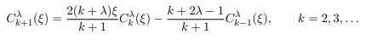 The IPRM, as discussed here and in [1], hinges on the changing the basis set of the initial image to a basis set that is less impacted by noise, that of the Gegenbauer polynomial. The Gegenbauer polynomial is defined as[4]

(1)

where k is the order of the polynomial, **ξ is the instance in time (or the associated pixel value as will be shown), and λ is a value that corresponds to the dimensionality of the input function and will be addressed later.[9] The Gegenbauer Polynomial for order k=1 is defined as 2*λ*ξ, and for k=0 is defined equal to 1.**

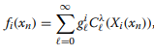 **The series expansion of the Gegenbauer Polynomial is then expressed as[1]**

(2)

where here l is the order (previously shown as k in 1).

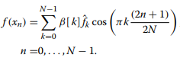 The definition of the DCT expansion is given as

(3)

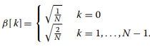where *f*k is the input function, N is the number of elements in the image or signal, and β[k] is the DCT normalization factor, defined as follows.

(4)

It is noted in [1] that eqn. 3 is the function that introduces the Gibbs phenomenon into the solution image.

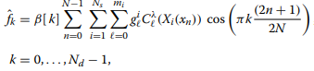 From here we substitute eqn. 2 into eqn. 3 to come to the noise resistant, compressed transmission function (*f*k) of

(5)

where Nd is the number of elements in the image Xi(xn). Here I make the assertion that for all signals and images considered, the element spacing is linear and equivalent. This allows me to take advantage of the linear mapping

 (6)

resulting in no change to the inputs. This means that, in eqn. 5, Xi(xn) = **ξ (where ξ is the original input).**

**From here, the article redefines the DCT portion of eqn. 5 as W and the Gegenbauer coefficients as G, such that**

f = W.G (7)

Therefore, by taking the pseudo-inversion of W, Wt, we finally arrive at

G = Wt.f (8)

where eqn. 8 is the definition of IPRM for the DCT.

The definition of **λ is related to the dimensionality of the function being considered. There number of dimensions, Z, is defined as**

**2λ + 2 = Z (10)**

such that a 1D signal results in **λ = 1.5[9].**

**4 Results**

I began by considering the simplest application of the IPRM, that of a 1D signal. To validate that my results match that of the article, I recreated the original signal

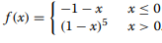 (9)

where the signal f(x) is referred to in the paper (and from here forward) as *f*1. The recreated signal *f*1, as well as the resultant frequency domain DCT of *f*1, is shown in Fig. 1. Similarly, I recreated the Heavisine function that was used for *f*2, as it is named in the article, and showed it with the frequency domain of its DCT, Fig. 2 shows the results.

From this point, I introduce the Gibbs phenomenon into the signals *f*1 and *f*2. This is done by truncating the second half of the frequency domain. The resultant image may achieve a modest compressed ratio of 2. This is done for all signals and images to maintain consistency of results. The resultant truncated signals *f*1 and *f*2 are shown with the accompanying inverse DCT signals in Fig. 3 and Fig. 4, respectively.

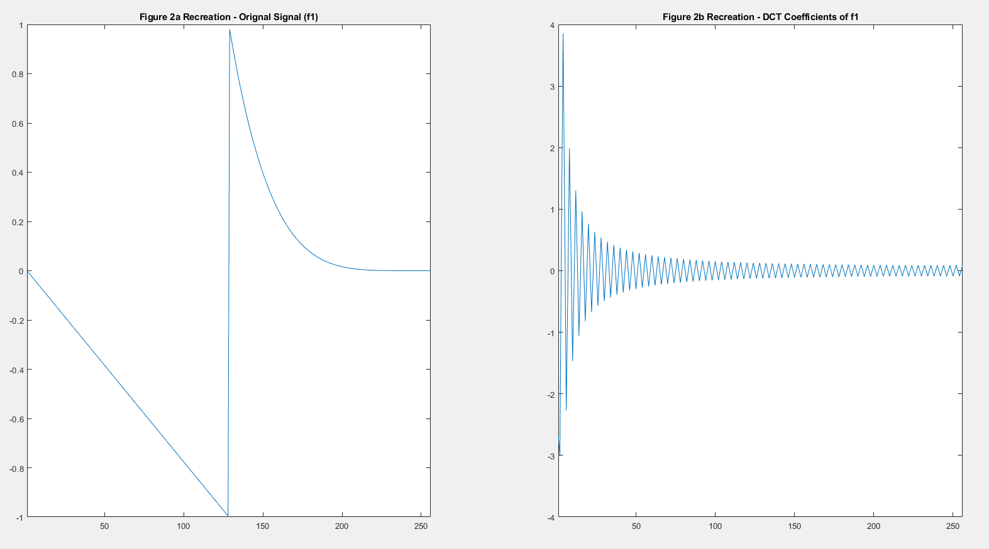

Figure 1: A recreation of Figure 2a (left) and 2b (right) from the arictle [1]. This shows the function f1 and the frequency domain of if DCT.

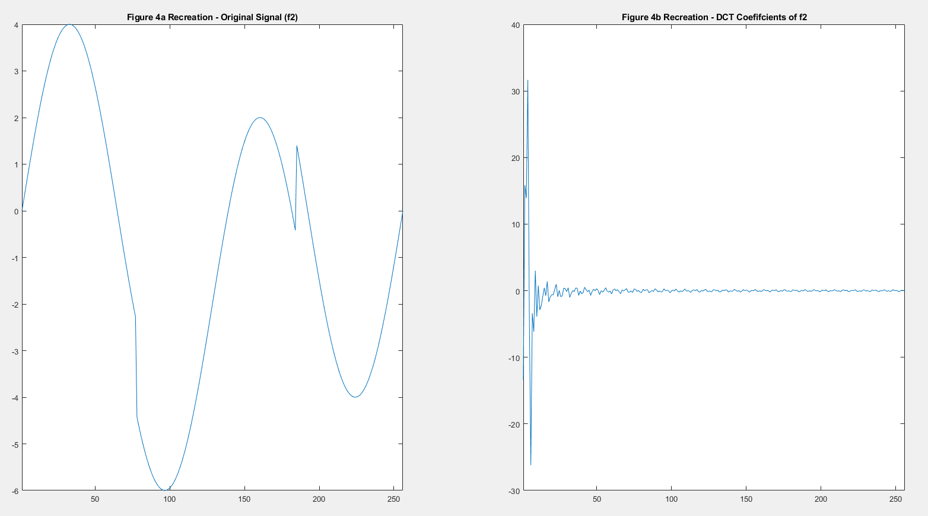

Figure 2: A recreation of Figure 4a (left) and 4b (right) from the arictle [1]. This shows the function f2 and the frequency domain of if DCT.

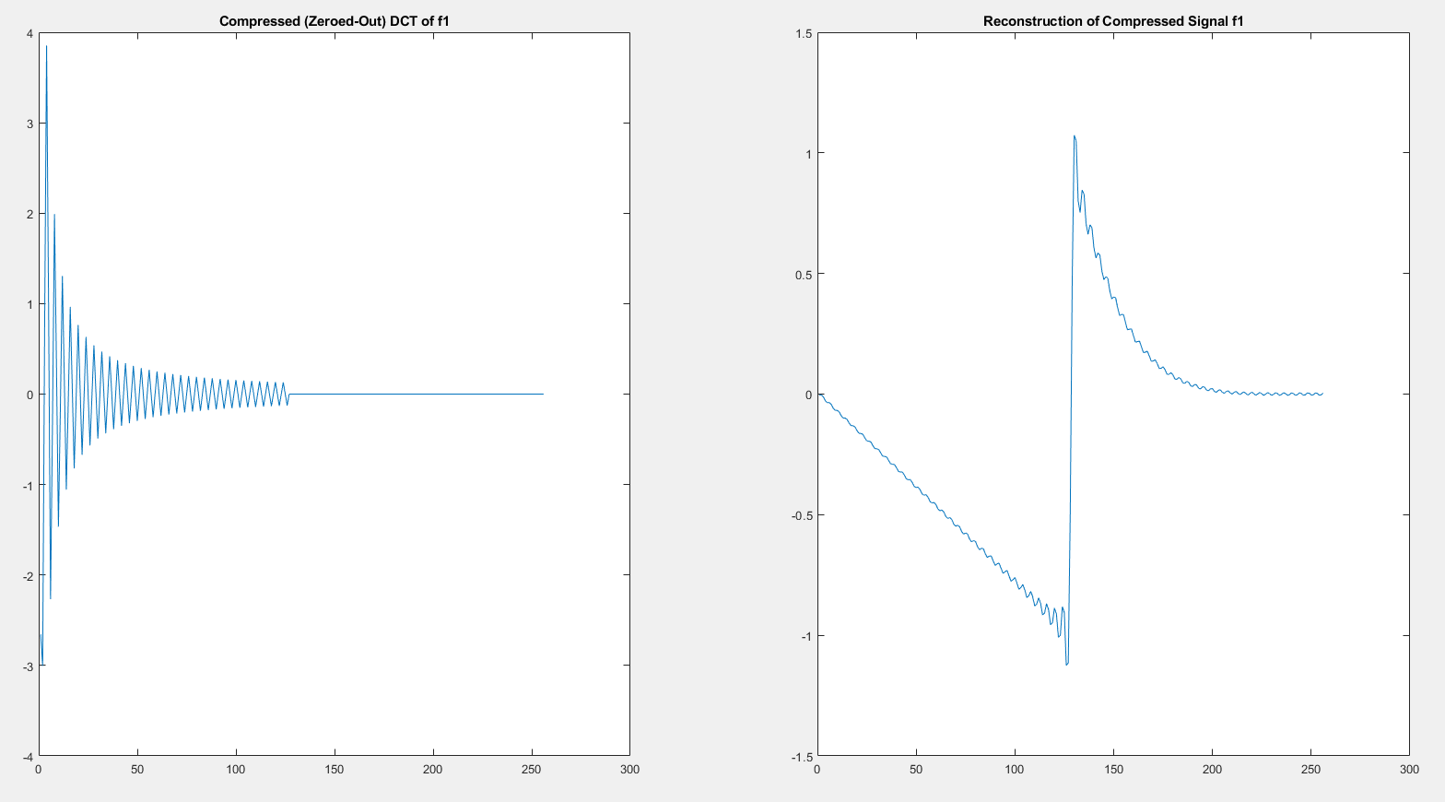

Figure 3: (a) shows the truncated signal f1 in the frequency domain and (b) shows the resultant time domain signal with the induced Gibbs phomenon.

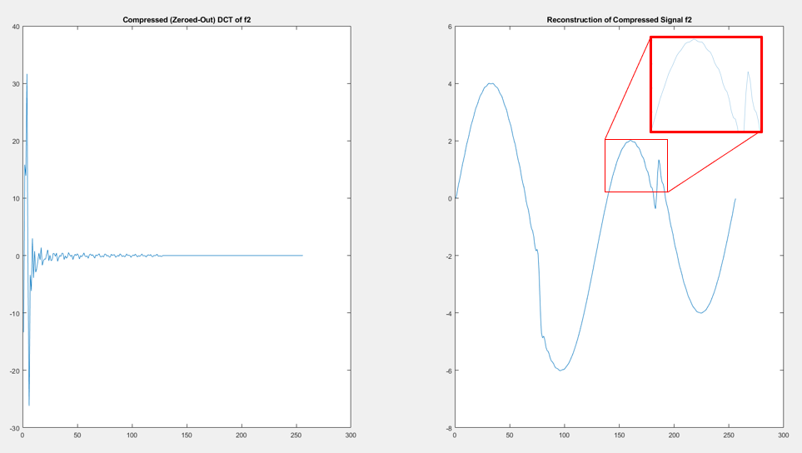

Figure 4: (a) shows the truncated signal f2 in the frequency domain and (b) shows the resultant time domain signal with the induced Gibbs phomenon highlight by the red box.

Following the validation of inputs, I validate the output of my Gegenbauer polynomial generating function. I generate a linear signal spanning [-1, 1] as input and plotted the output for the first five degrees of the Gegenbauer polynomial expansion. In Fig. 5, the outputs can be seen as matching the expected results[10].

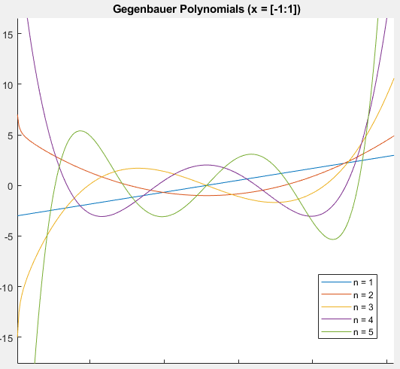

Figure 5: A plot of an N-degree Gegenbauer Polynomial for n = 1:5, that corresponds to the expected result[10].

I then validate the entire IPRM by using the already validated signals *f*1 and *f*2, and following the procedures described in section 3 (above). These results are shown in Fig. 6 and Fig. 7, respectively. To support analysis of the outputs, I create a root-mean-square error graph of the IPRM outputs and input. This analysis, shown in Fig. 8 and Fig. 9 (respectively), shows that the signals are both different from the input functions and free of the Gibbs phenomenon.

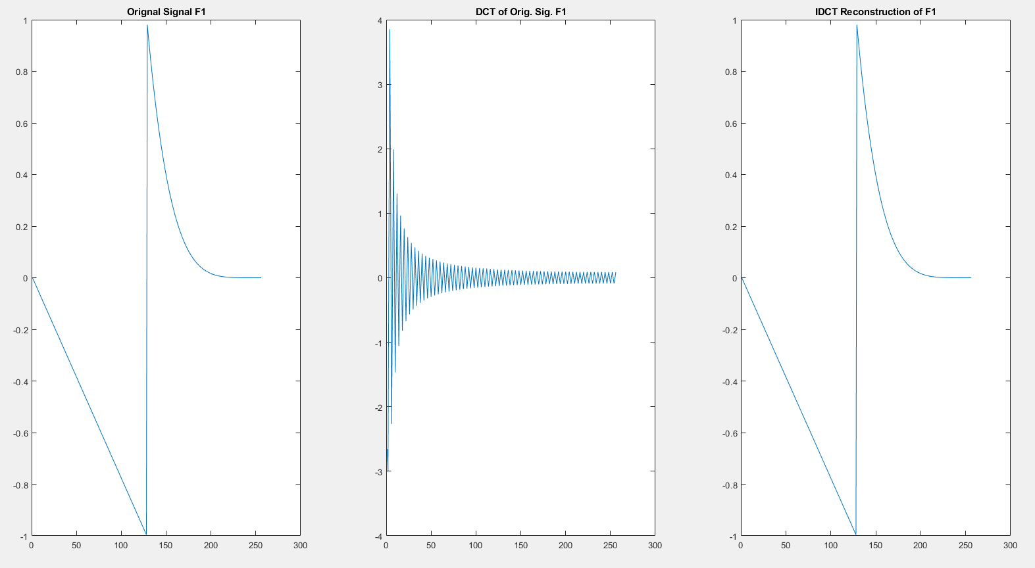

Figure 6: (a) The input signal, f1, to the IPRM. (b) The frequency domain of the input signal, f1, after truncation and change of basis to the Gegenbauer Polynomial basis set. (c) The resultant of the IPRM for input signal (b).

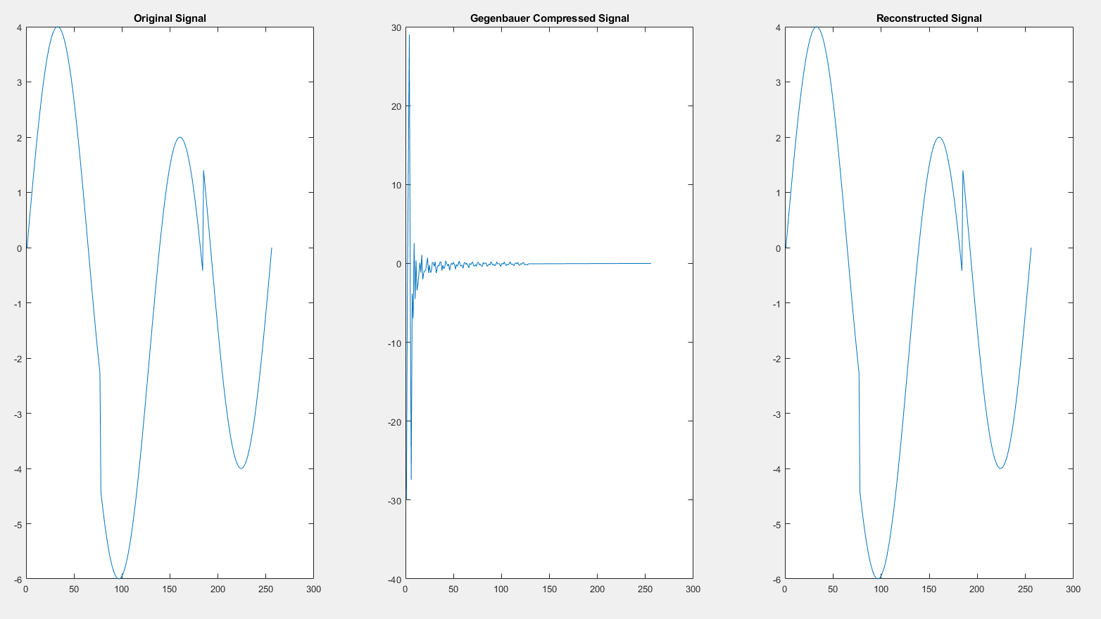

Figure 7: (a) The input signal, f2, to the IPRM. (b) The frequency domain of the input signal, f2, after truncation and change of basis to the Gegenbauer Polynomial basis set. (c) The resultant of the IPRM for input signal (b).

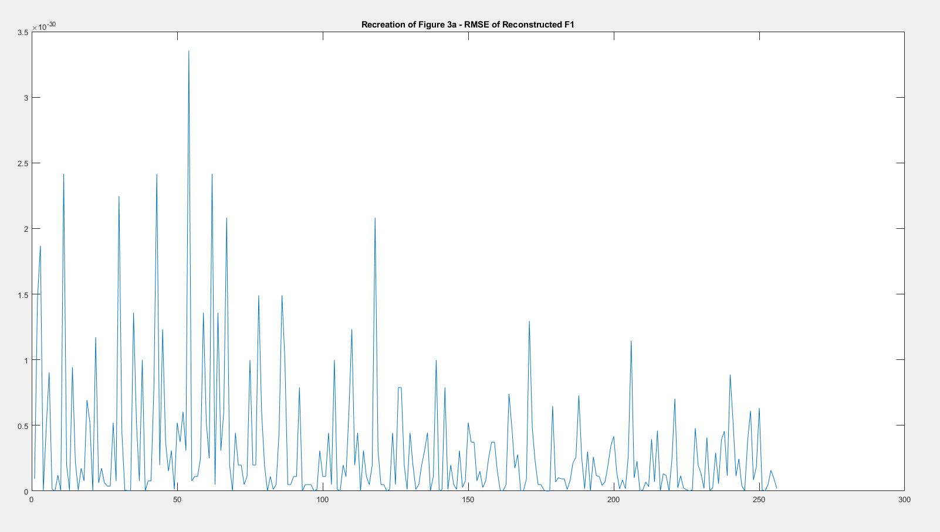

Figure 8: A recreation of Figure 3a from the reference article [1]. The root-mean-square error of the signal f1 and its corresponding IPRM output.

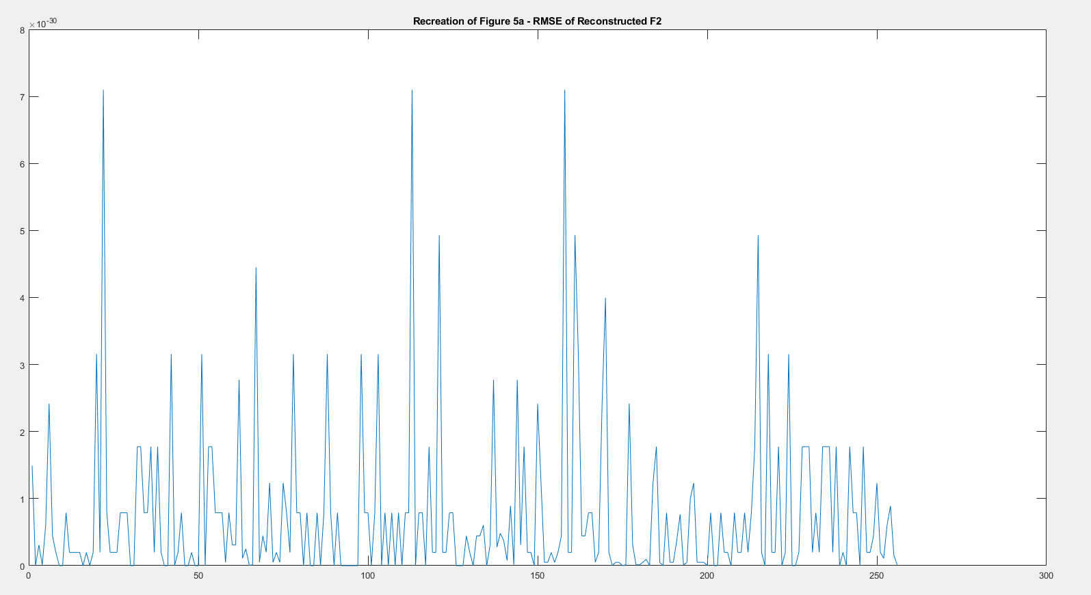

Figure 9: A recreation of Figure 5a from the reference article [1]. The root-mean-square error of the signal f2 and its corresponding IPRM output.

After validating the simplest 1D case I begin to study IPRM efficacy on 2D images, as in the progression of the article [1]. For each image considered, I plot the original image with the Gegenbauer basis set image (post compression) in the frequency domain. I also show a 1D plot showing that the image pre- and post- truncation (compression). I then show the results of the IPRM in comparison to the original image and the image corrupted by the Gibbs phenomenon. Additionally, I show the effects of the IPRM to reduce noise to a great extent[6] at SNR levels of 3dB, 10dB, and -10dB. The noise generated is Gaussian white noise. Finally, I display the root-mean-square error of the IPRM with reference to the images input with no additional noise and the image with SNR or -10dB.

The first image considered is the ‘cameraman.tif’ image which is built into MatLab by default. In Fig. 10, I show the cameraman image, its Gegenbauer compressed image of a new basis, and a 1D representation of each in frequency domain to show the image truncation.

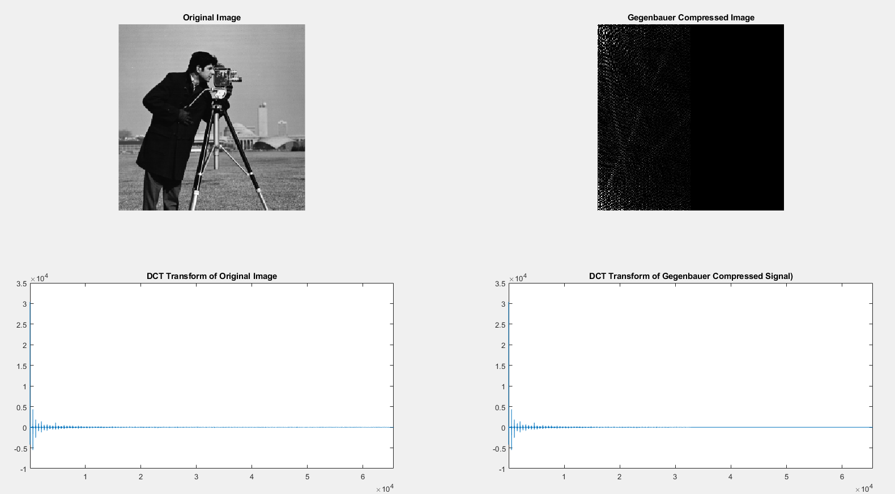

Figure 10: (a) The MatLab built-in image ‘cameraman.tif’. (b) The image (a) after Gegenbauer encoding, DCT, and truncation. (c) The 1D frequency domain of (a). (d) The 1D frequency domain of (b).

In Fig. 11, I show the cameraman image and its comparison the same image with the Gibbs phenomenon present and the results of IPRM on Figure 11b.

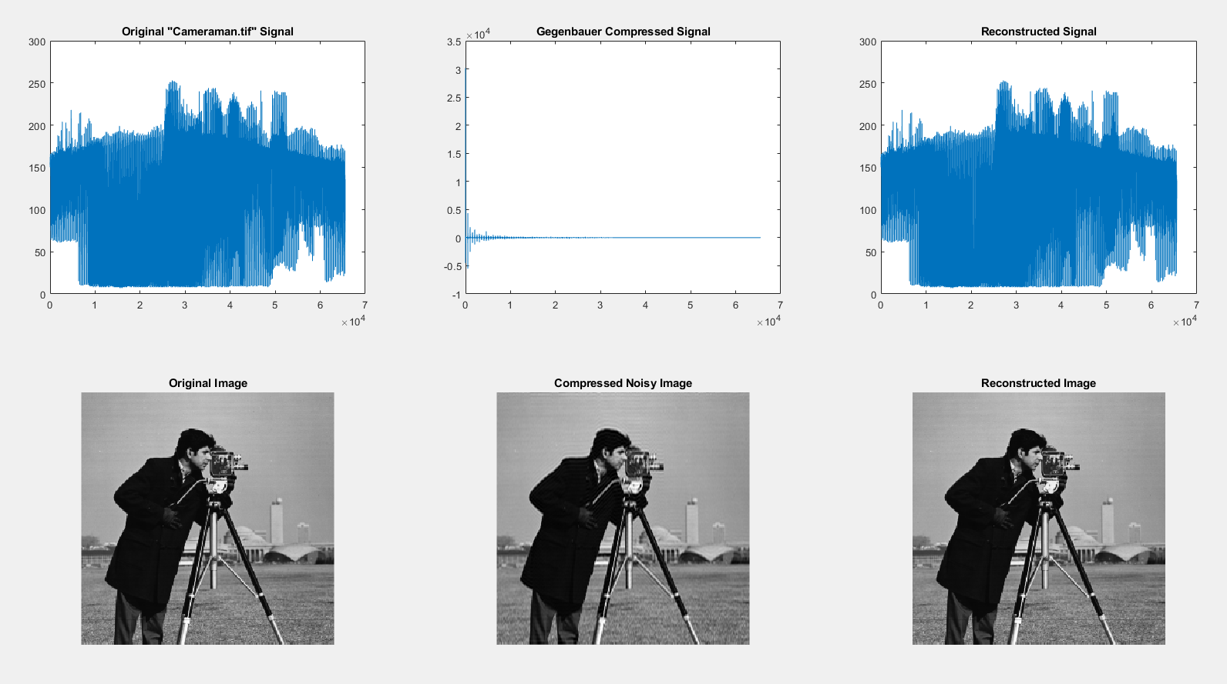

Figure 11: (a) The MatLab built-in image ‘cameraman.tif’. (b) The result of the image truncation shown in 10d. (c) The image (a) after undergoing the IPRM.

I show that the IPRM reduces noise, in Fig. 12, with images at noise levels of SNR = 3dB, 10dB. and -10dB. Then I show, in Fig. 13, the root-mean-square errors of the image reconstructed without additional noise (Fig. 11c) and the image reconstructed with an SNR = -10dB (Fig. 12f).

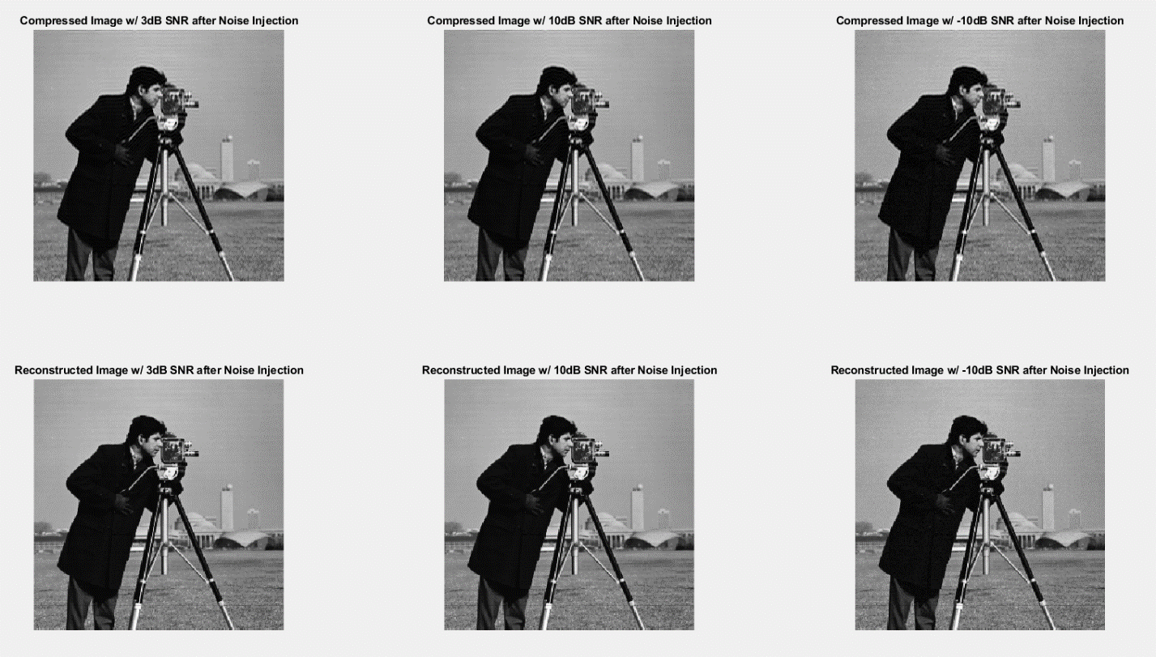

Figure 12: (a) Fig. 10a reconstructed without IPRM at an SNR = 3dB (b) Fig. 10a reconstructed without IPRM at an SNR = 10dB (c) Fig. 10a reconstructed without IPRM at an SNR = -10dB (d) Fig. 10a reconstructed with IPRM at an SNR = 3dB (e) Fig. 10a reconstructed with IPRM at an SNR = 10dB (f) Fig. 10a reconstructed with IPRM at an SNR = -10dB

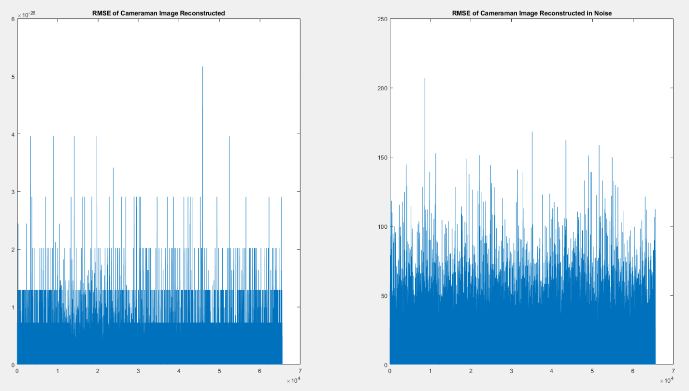

Figure 13: (a) Root-mean-square error of Fig. 10a and Fig 11c. (b) Root-mean-square error of Fig. 10a and Fig 12f.

The second image considered is the ‘cell.tif’ image which is built into MatLab by default. In Fig. 14, I show the cell image, its Gegenbauer compressed image of a new basis, and a 1D representation of each in frequency domain to show the image truncation.

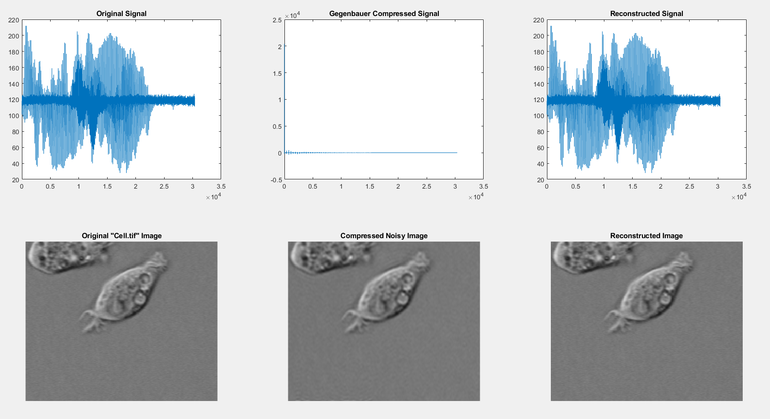

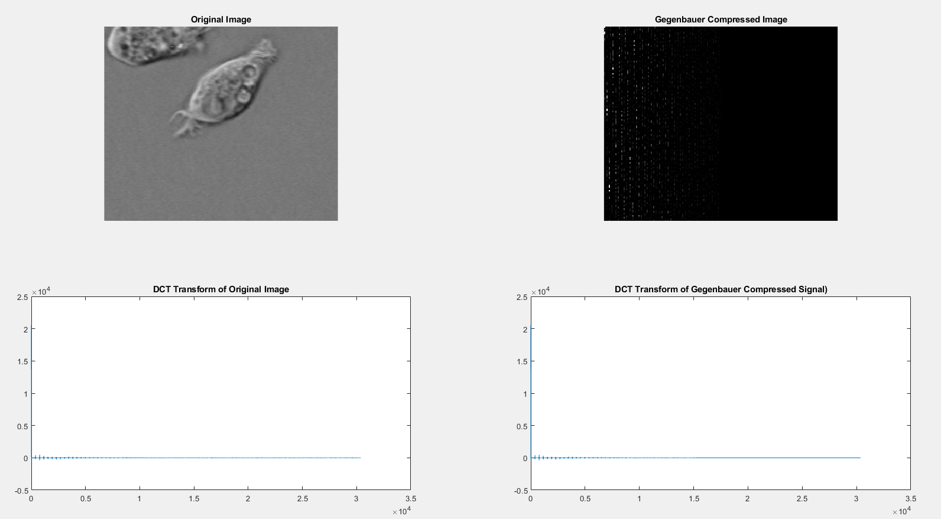

Figure 14: (a) The MatLab built-in image ‘cameraman.tif’. (b) The image (a) after Gegenbauer encoding, DCT, and truncation. (c) The 1D frequency domain of (a). (d) The 1D frequency domain of (b).

In Fig. 15, I show the cell image and its comparison the same image with the Gibbs phenomenon present and the results of IPRM on Figure 14b.

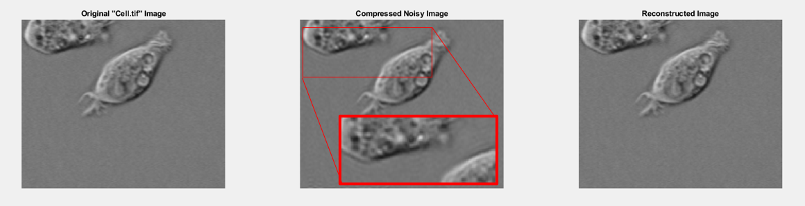

Figure 15: (a) The MatLab built-in image ‘cell.tif’. (b) The result of the image truncation shown in 14d, with the very slight Gibbs Phenomenon highlighted. (c) The image (a) after undergoing the IPRM.

I show that the IPRM reduces noise, in Fig. 16, with images at noise levels of SNR = 3dB, 10dB. and -10dB. Then I show, in Fig. 17, the root-mean-square errors of the image reconstructed without additional noise (Fig. 15c) and the image reconstructed with an SNR = -10dB (Fig. 16f).

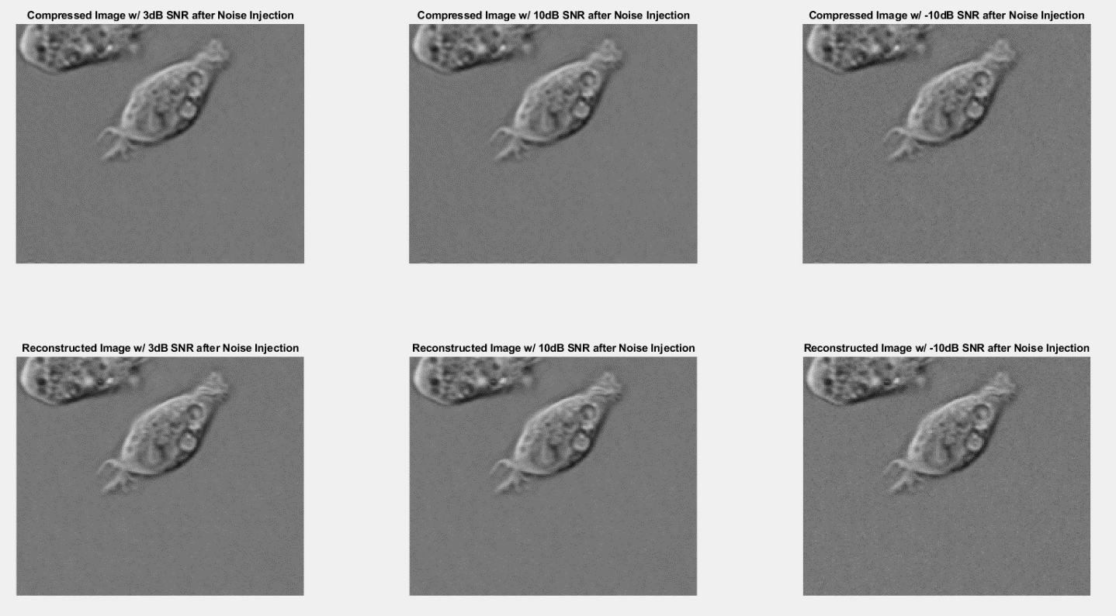

Figure 16: (a) Fig. 14a reconstructed without IPRM at an SNR = 3dB (b) Fig. 14a reconstructed without IPRM at an SNR = 10dB (c) Fig. 14a reconstructed without IPRM at an SNR = -10dB (d) Fig. 14a reconstructed with IPRM at an SNR = 3dB (e) Fig. 14a reconstructed with IPRM at an SNR = 10dB (f) Fig. 14a reconstructed with IPRM at an SNR = -10dB

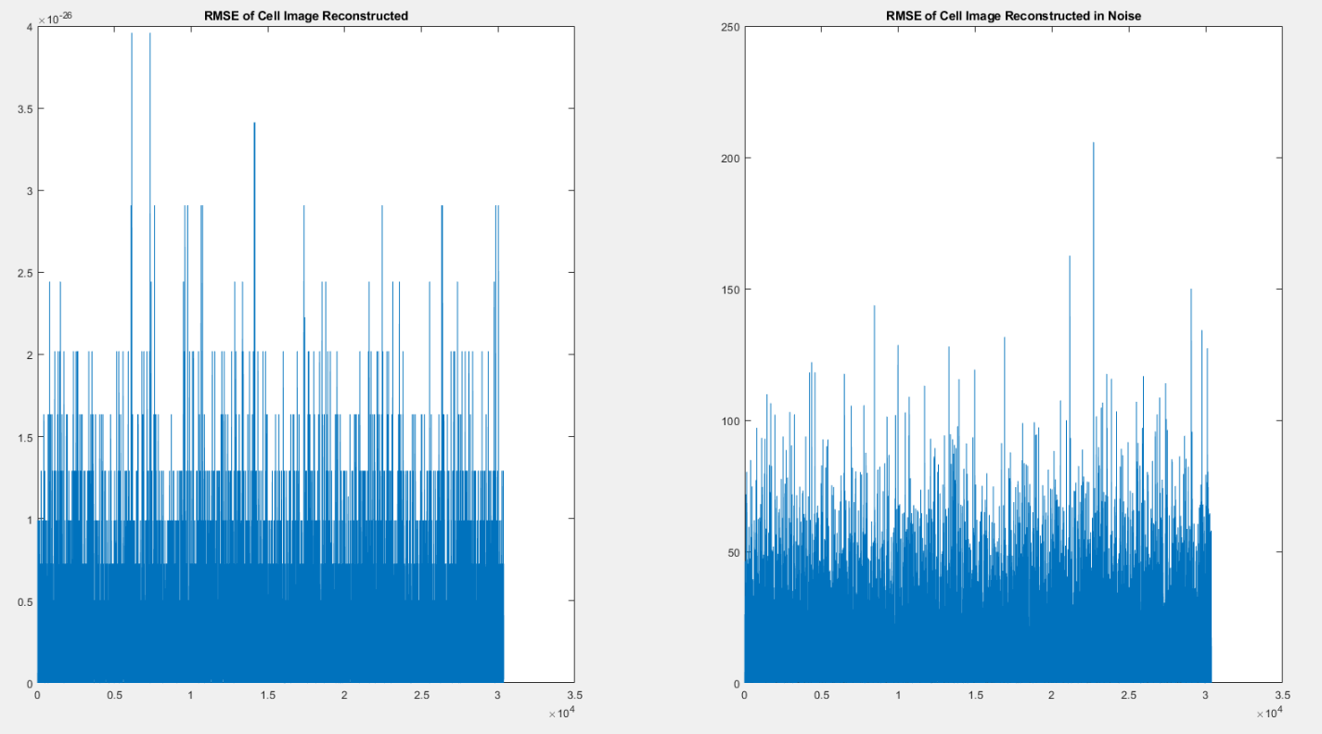

Figure 17: (a) Root-mean-square error of Fig. 14a and Fig 15c. (b) Root-mean-square error of Fig. 14a and Fig 16f.

For the third image, I consider the ‘manid.tif’ image which is built into MatLab by default. In Fig. 18, I show image of Mandi, its Gegenbauer compressed image of a new basis, and a 1D representation of each in frequency domain to show the image truncation.

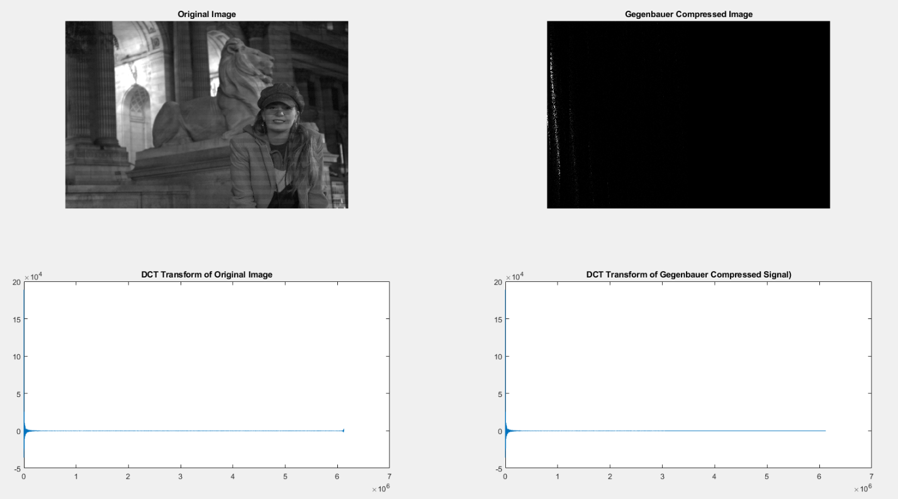

Figure 18: (a) The MatLab built-in image ‘mandi.tif’. (b) The image (a) after Gegenbauer encoding, DCT, and truncation. (c) The 1D frequency domain of (a). (d) The 1D frequency domain of (b).

In Fig. 19, I show the Mandi image and its comparison the same image with the Gibbs phenomenon present and the results of IPRM on Figure 19b.

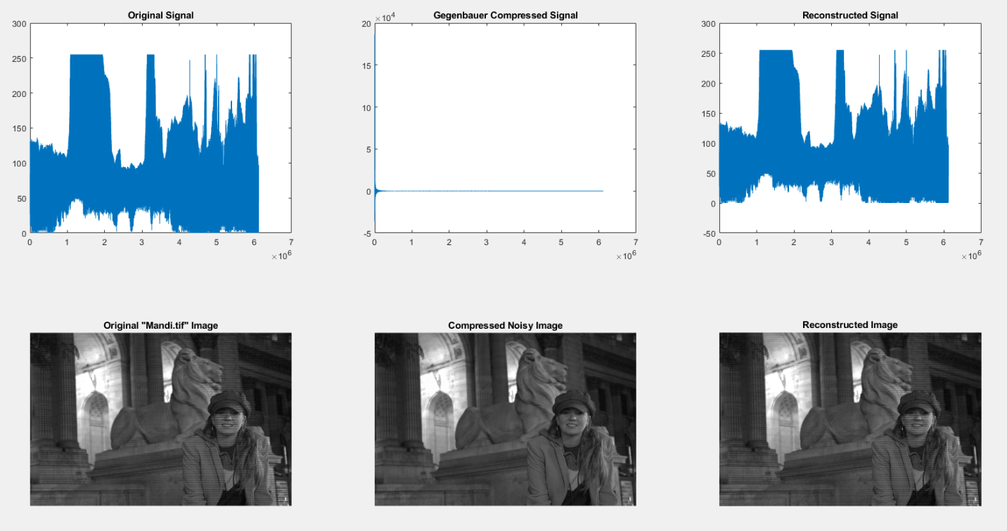

Figure 19: (a) The MatLab built-in image ‘mandi.tif’. (b) The result of the image truncation shown in 18d. (c) The image (a) after undergoing the IPRM.

I show that the IPRM reduces noise, in Fig. 20, with images at noise levels of SNR = 3dB, 10dB. and -10dB. Then I show, in Fig. 21, the root-mean-square errors of the image reconstructed without additional noise (Fig. 19c) and the image reconstructed with an SNR = -10dB (Fig. 12f).

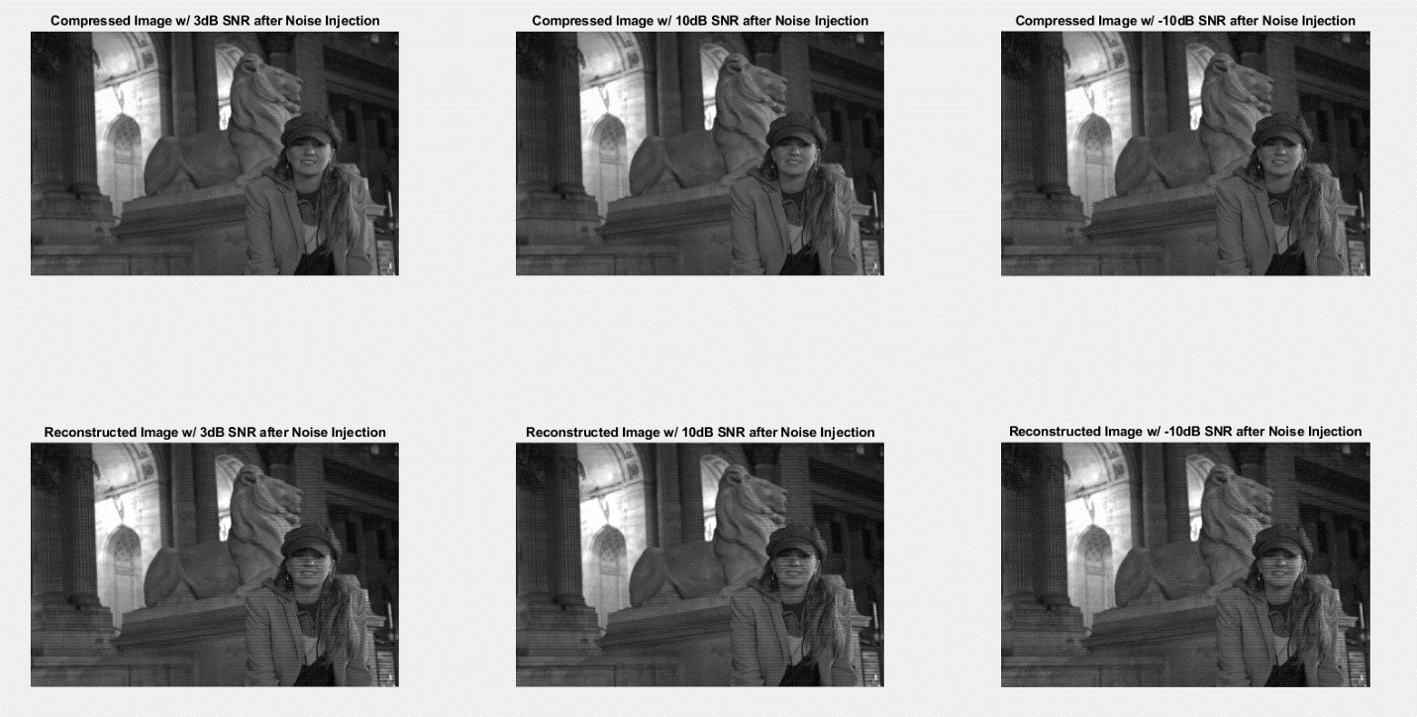

Figure 20: (a) Fig. 18a reconstructed without IPRM at an SNR = 3dB (b) Fig. 18a reconstructed without IPRM at an SNR = 10dB (c) Fig. 18a reconstructed without IPRM at an SNR = -10dB (d) Fig. 18a reconstructed with IPRM at an SNR = 3dB (e) Fig. 18a reconstructed with IPRM at an SNR = 10dB (f) Fig. 18a reconstructed with IPRM at an SNR = -10dB

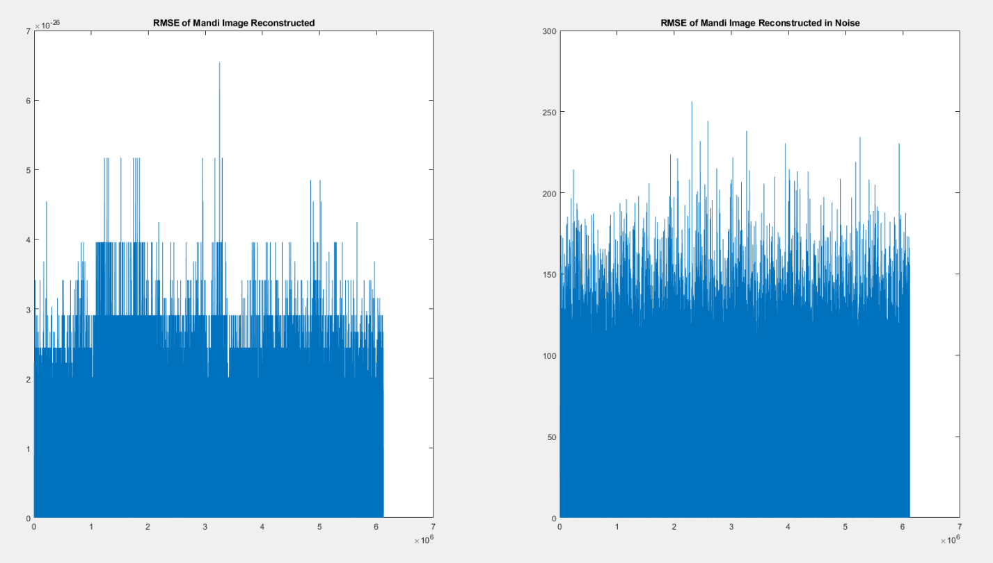

Figure 21: (a) Root-mean-square error of Fig. 18a and Fig 19c. (b) Root-mean-square error of Fig. 18a and Fig 20f.

Likewise, the next image considered is the ‘moon.tif’ image which is built into MatLab by default. In Fig. 22, I show the moon image, its Gegenbauer compressed image of a new basis, and a 1D representation of each in frequency domain to show the image truncation.

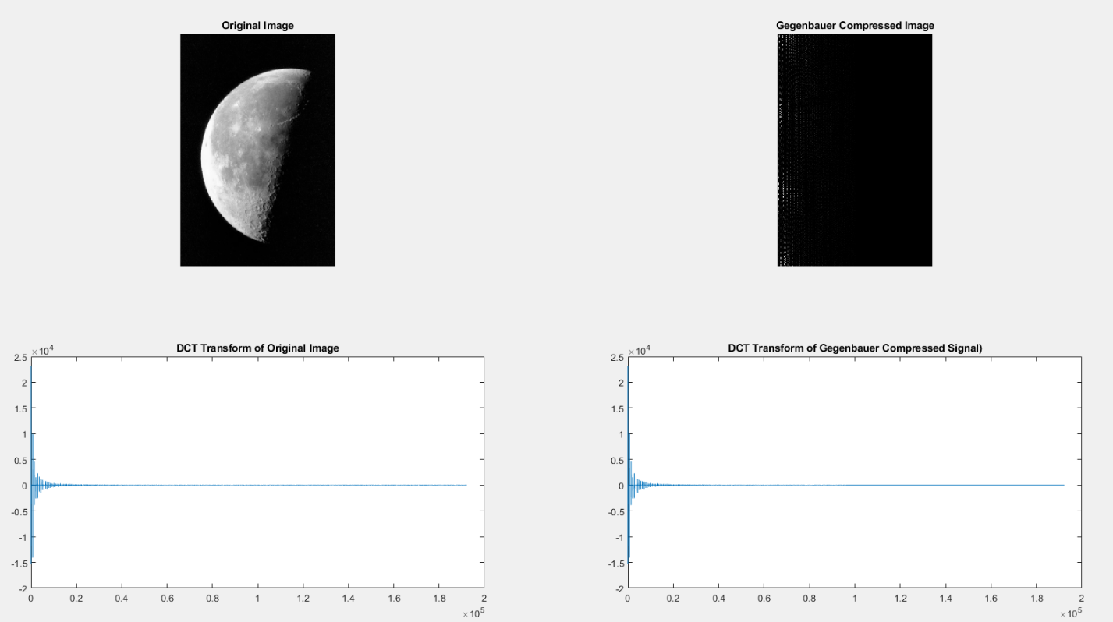

Figure 22: (a) The MatLab built-in image ‘moon.tif’. (b) The image (a) after Gegenbauer encoding, DCT, and truncation. (c) The 1D frequency domain of (a). (d) The 1D frequency domain of (b).

In Fig. 23, I show the moon image and its comparison the same image with the Gibbs phenomenon present and the results of IPRM on Figure 23b.

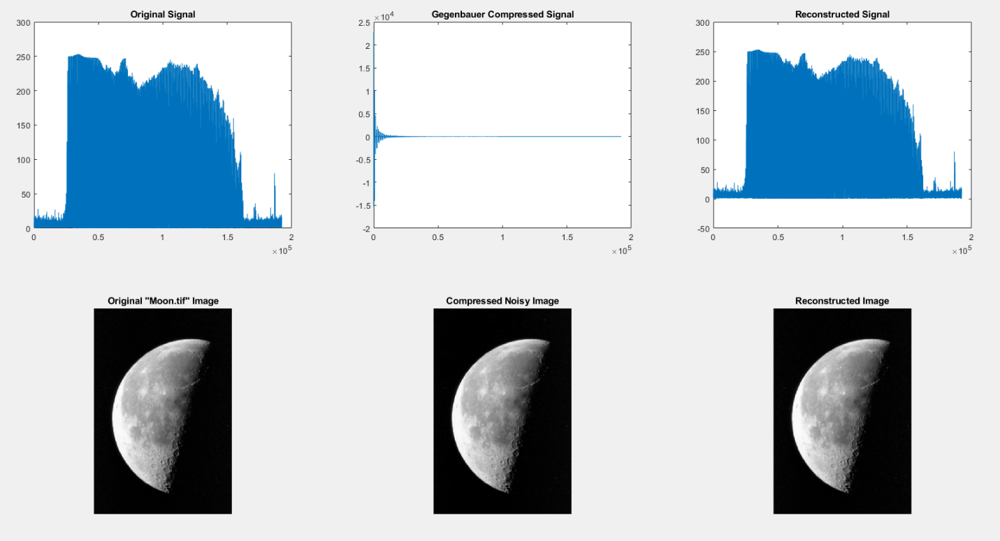

Figure 23: (a) The MatLab built-in image ‘moon.tif’. (b) The result of the image truncation shown in 22d. (c) The image (a) after undergoing the IPRM.

I show that the IPRM reduces noise, in Fig. 24, with images at noise levels of SNR = 3dB, 10dB. and -10dB. Then I show, in Fig. 25, the root-mean-square errors of the image reconstructed without additional noise (Fig. 23c) and the image reconstructed with an SNR = -10dB (Fig. 24f).

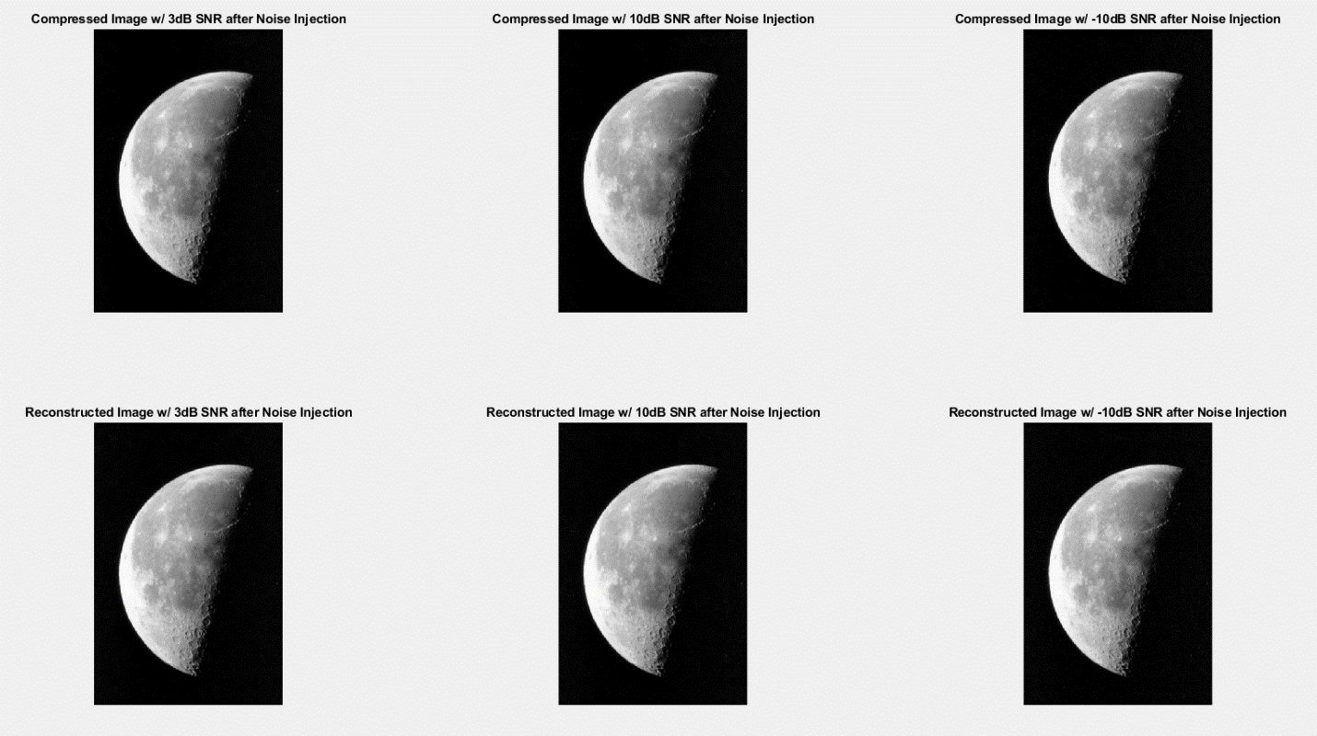

Figure 24: (a) Fig. 22a reconstructed without IPRM at an SNR = 3dB (b) Fig. 22a reconstructed without IPRM at an SNR = 10dB (c) Fig. 22a reconstructed without IPRM at an SNR = -10dB (d) Fig. 22a reconstructed with IPRM at an SNR = 3dB (e) Fig. 22a reconstructed with IPRM at an SNR = 10dB (f) Fig. 22a reconstructed with IPRM at an SNR = -10dB

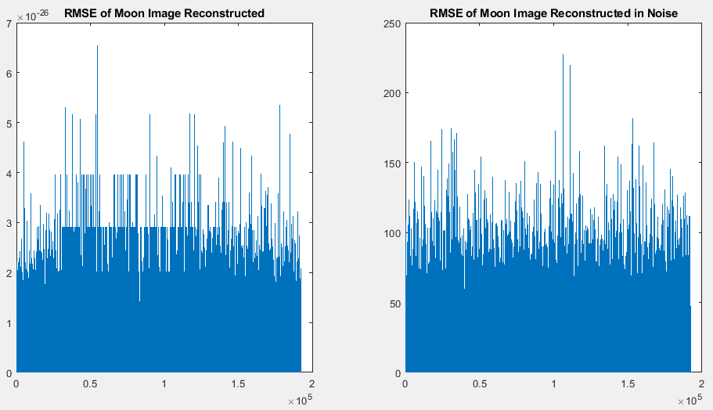Figure 25: (a) Root-mean-square error of Fig. 22a and Fig 23c. (b) Root-mean-square error of Fig. 22a and Fig 24f.

The final image considered is the ‘pout.tif’ image which is built into MatLab by default. In Fig. 26, I show the image of the pouting child, its Gegenbauer compressed image of a new basis, and a 1D representation of each in frequency domain to show the image truncation.

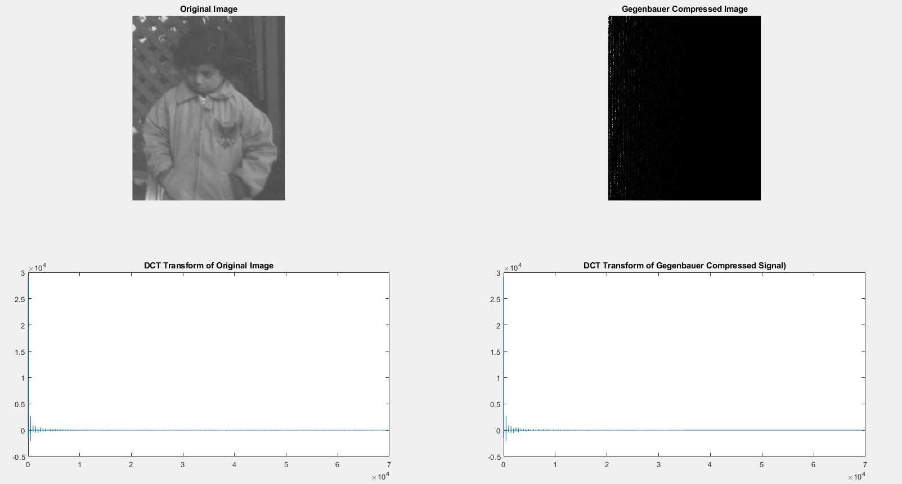

Figure 26: (a) The MatLab built-in image ‘pout.tif’. (b) The image (a) after Gegenbauer encoding, DCT, and truncation. (c) The 1D frequency domain of (a). (d) The 1D frequency domain of (b).

In Fig. 27, I show the pouting image and its comparison the same image with the Gibbs phenomenon present and the results of IPRM on Figure 27b.

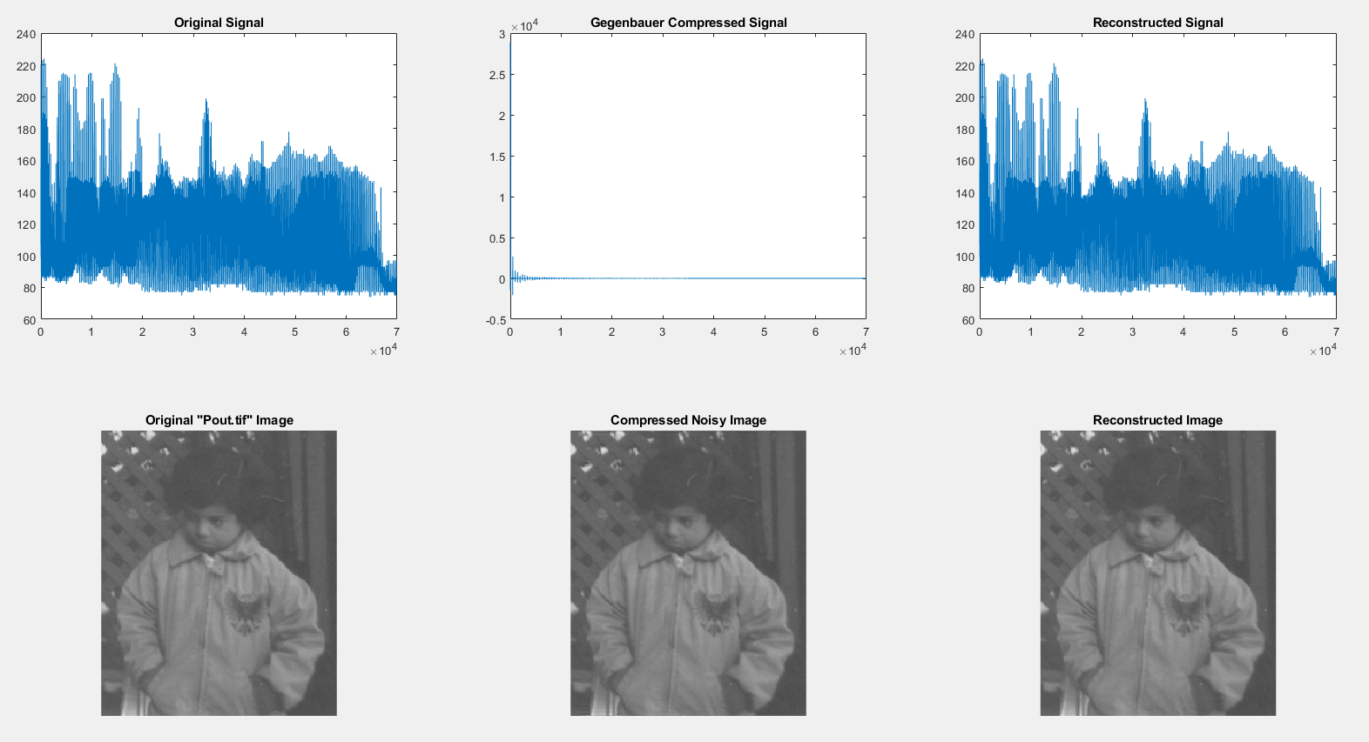

Figure 27: (a) The MatLab built-in image ‘pout.tif’. (b) The result of the image truncation shown in 10d. (c) The image (a) after undergoing the IPRM.

I show that the IPRM reduces noise, in Fig. 28, with images at noise levels of SNR = 3dB, 10dB. and -10dB. Then I show, in Fig. 29, the root-mean-square errors of the image reconstructed without additional noise (Fig. 27c) and the image reconstructed with an SNR = -10dB (Fig. 28f).

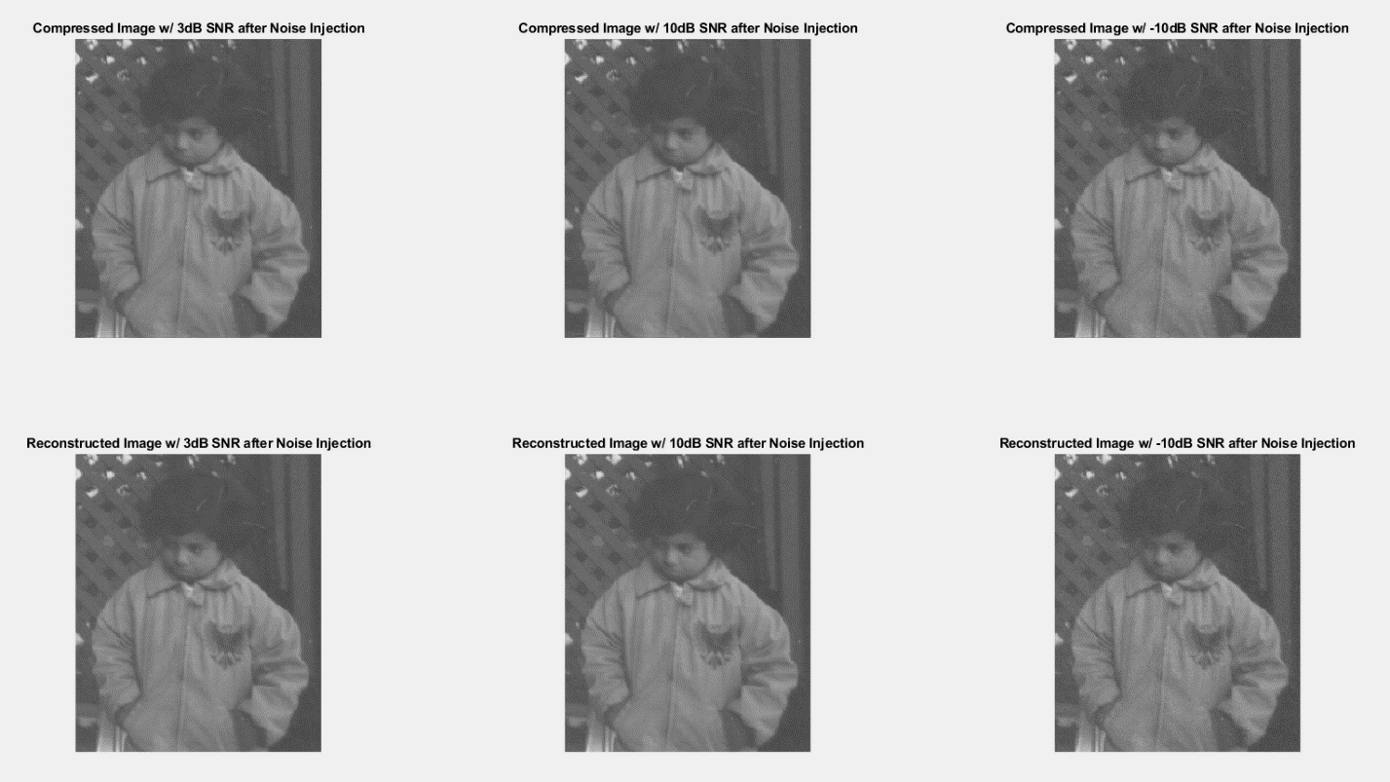

Figure 28: (a) Fig. 26a reconstructed without IPRM at an SNR = 3dB (b) Fig. 26a reconstructed without IPRM at an SNR = 10dB (c) Fig. 26a reconstructed without IPRM at an SNR = -10dB (d) Fig. 26a reconstructed with IPRM at an SNR = 3dB (e) Fig. 26a reconstructed with IPRM at an SNR = 10dB (f) Fig. 26a reconstructed with IPRM at an SNR = -10d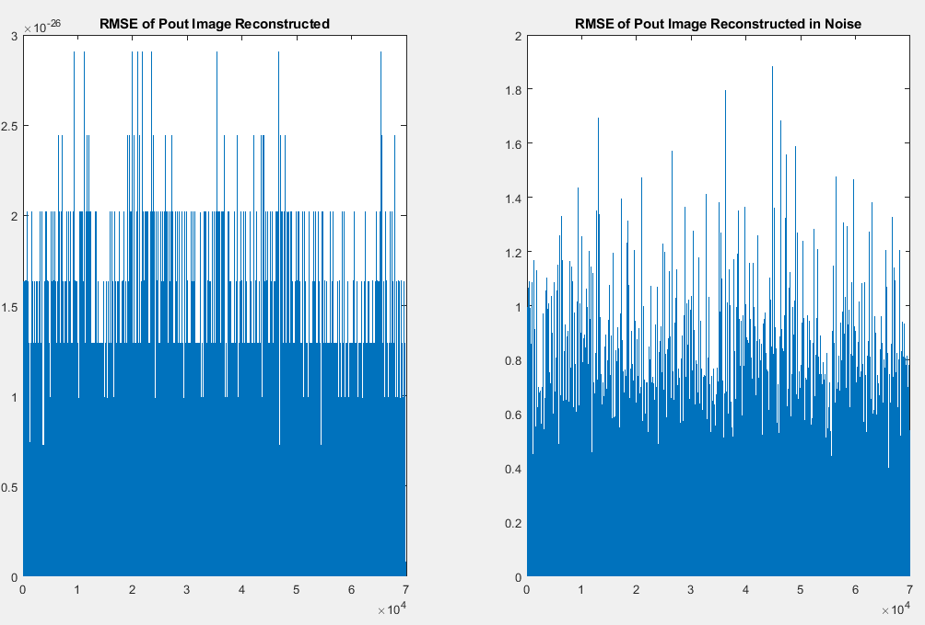Figure 29: (a) Root-mean-square error of Fig. 26a and Fig 27c. (b) Root-mean-square error of Fig. 26a and Fig 28f.

**5 Discussion of Results**

The existence of the Gibbs phenomenon was not apparent in all images. Furthermore, some images had very unexpected responses to the introduction of the Gibbs phenomenon. As expected, the introduction of the Gibbs phenomenon creates a ‘ringing’ effect that can be seen in the signals generated as well as some of the images tested. This effect is shown for the 1D signals in Fig. 30 and for the most dramatically impacted images in Fig. 31, below.

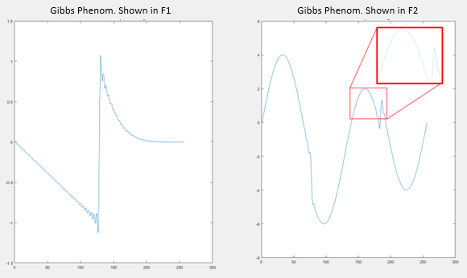

Figure 30: (a) Gibbs phenomenon presented in F1, as seen in Fig. 3b. (b) Gibbs phenomenon presented in F2, as seen in Fig. 4b.

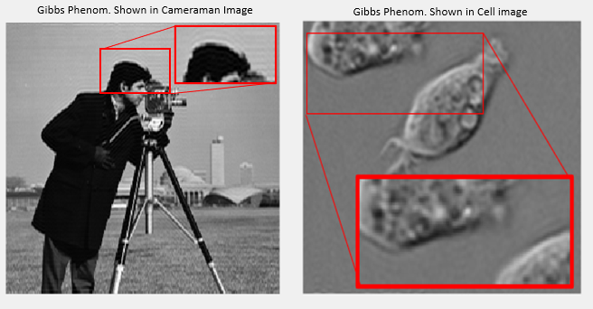

Figure 31: (a) Gibbs phenomenon presented the cameraman image, as seen in Fig. 11b, with an additional zoom box to highlight the ringing. (b) Gibbs phenomenon presented the cell image, as seen in Fig. 15b.

However, some images are much less effected by the introduction of the Gibbs phenomenon. For example, the pout image (Fig. 27b) has an almost imperceptibly small ringing introduced as a result of the Gibbs phenomenon. This minute effect is shown in Fig. 32, below.

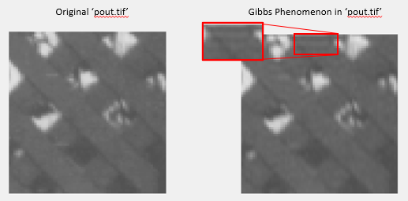

Figure 32: (a) The original ‘pout.tif’ image. (b) The ‘pout.tif’ image after the Gibbs phenomenon is introduced.

Moreover, the moon image (Fig. 23b) does not show any indication of the ringing that is characteristic of the Gibbs phenomenon. The pattern emerging seems to indicate that images and signals with higher periodicity or more high frequency components are less likely to demonstrate the Gibbs phenomenon ringing.

To further that point, I will now highlight the results of Fig.19. The original image ‘mandi.tif’, as it was imported by MatLab, showed a distinct high frequency grid pattern overlaying the image. Unexpectedly, this high frequency pattern was completely removed in the attempted application of the Gibbs phenomenon. This is shown below in Fig 33, which is an enlarged form of Fig 19a and 19b. Despite this oddity, the root-mean-square error of the image noise level improved on the same order of magnitude of all the other images and signals.

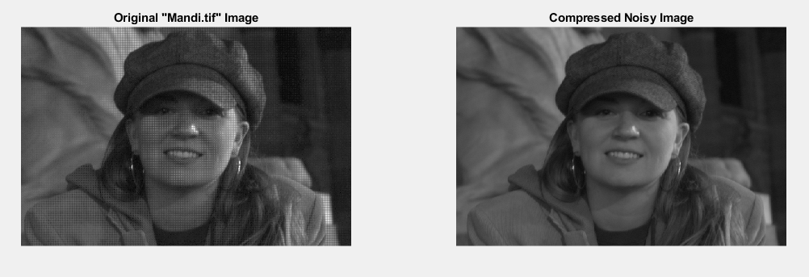

Figure 33: (a) The original ‘mandi.tif’ image imported from MatLab, with a noise pattern overlaid. This is a zoomed in form of Fig. 19a. (b) The result of frequency domain truncation, as shown in Fig. 19b, showing the anomalous removal of noise instead of a Gibbs phenomenon pattern.

The root-mean-square error for all images, with and without Gaussian noise error injection, are within one or two orders of magnitude of the others. This is exactly the expected result, and can be explained by the constant expansion length and polynomial degree of the IPRM applied to each image and signal[1][6][9]. That is to say, maintaining the same **λ=1.5 and k=2.5 defined in section 3 are expected to result in a similar improvement in noise level for similar images.**

**6 Discussion**

The results of article [1] were successfully replicated in the manner stated in my project proposal. I was able to replicate Figure 2 and Figure 4 from article [1]. Additionally, I was able to recreate the noise assessment plots shown in Figure 3a and Figure 5a from the article. Following the recreation of these figures, I was able to replicate an IPRM function that produces images without the Gibbs phenomenon. To further show the success of the IPRM replication, I show the IPRM propensity for denoising images. These applications are discussed in article [1] sections 3.3 and 4.1.

In the development of this processing, I had to become well acquainted with the mathematically definitions and applications of Gegenbauer polynomials, which consumed a vast majority of the time invested into this project. This admittedly significant delay in progress prevented me from replicating the “Easy Path Wavelet Transform” approximation and sorting procedure described in section 4.2. Furthermore, the results of this project show include interesting and unexpected features (discussed in section 5) which warrant investigation and characterization. I suspect that the abnormal behavior is related to the frequency spectra of the image prior to truncation or transformation. Accordingly, I believe a simple Gaussian lowpass filter would result in a removal of this odd occurrence. This seems out of scope of the project, however. Thus due to time restriction, I was not able to properly investigate this hypothesis.

To accomplish the successful portions of this replication of work, I was forced to extend the knowledge learned in the course to an application that is still very relevant in industry. This project involved an assessment of image compression, induced noise and the signal to noise ratios of images, the application of discrete cosine transformations and consideration of its differences from the Fourier transform (particularly in the reprojection process to reconstruct input images), and the effects of changing polynomial basis of a signal. This single project spans topics covered in five on the eight projects assigned in this course. At the same time, however, this project goes far beyond the classical topics covered in both difficulty and modern applicability.

**7 References**

1. Dadkhahi et al.: Inverse polynomial reconstruction method in DCT domain. EURASIP Journal on Advances in Signal Processing 2012 2012:133.
2. Walter, G.G., Shim, HT. Gibbs' phenomenon for sampling series and what to do about it. *The Journal of Fourier Analysis and Applications* **4,**357–375 (1998). <https://doi.org/10.1007/BF02476033>
3. J. H. Jung, B. D. Shizgal. Inverse Polynomial Reconstruction of Two Dimensional Fourier Images. Journal of Scientific Computing. Vol 25, No 3. December 2005. DOI: 10.1007/s10915-004-4795-3.
4. S. A. Sarra. The MatLab Postprocessing Toolkit. Marshall University. July 2008.
5. [Weisstein, Eric W.](https://mathworld.wolfram.com/about/author.html) "Gegenbauer Polynomial." From [*MathWorld*](https://mathworld.wolfram.com/)--A Wolfram Web Resource. <https://mathworld.wolfram.com/GegenbauerPolynomial.html>
6. D. Gottlieb, C.-.W. Shu, A. Solomonoff, H. Vandeven. On the Gibbs phenomenon I: recovering exponential accuracy from the Fourier partial sum of a nonperiodic analytic function. J. Comput. Appl. Math., 43 (1992), pp. 81-98
7. Kim, D.S., Kim, T. & Rim, SH. Some identities involving Gegenbauer polynomials. *Adv Differ Equ* 2012, 219 (2012). https://doi.org/10.1186/1687-1847-2012-219
8. Parry Y. Chen, Yonatan Sivan, Resolving the Gibbs phenomenon via a discontinuous basis in a mode solver for open optical systems,Journal of Computational Physics, Volume 429, 2021, 110004, ISSN 0021-9991, <https://doi.org/10.1016/j.jcp.2020.110004>.
9. BD Shizgal, J-H Jung, Towards the resolution of the Gibbs phenomena, J. Comput. Appl. Math. 161(1), 41–65 (2003)
10. Johansson, Fredrik. “Orthogonal Polynomials.” From *mpmath*. February 2021. <https://mpmath.org/doc/current/functions/orthogonal.html>

**8 Figures**



Figure 1: A recreation of Figure 2a (left) and 2b (right) from the arictle [1]. This shows the function f1 and the frequency domain of if DCT.



Figure 2: A recreation of Figure 4a (left) and 4b (right) from the arictle [1]. This shows the function f2 and the frequency domain of if DCT.



Figure 3: (a) shows the truncated signal f1 in the frequency domain and (b) shows the resultant time domain signal with the induced Gibbs phomenon.



Figure 4: (a) shows the truncated signal f2 in the frequency domain and (b) shows the resultant time domain signal with the induced Gibbs phomenon highlight by the red box.



Figure 5: A plot of an N-degree Gegenbauer Polynomial for n = 1:5, that corresponds to the expected result[10].



Figure 6: (a) The input signal, f1, to the IPRM. (b) The frequency domain of the input signal, f1, after truncation and change of basis to the Gegenbauer Polynomial basis set. (c) The resultant of the IPRM for input signal (b).



Figure 7: (a) The input signal, f2, to the IPRM. (b) The frequency domain of the input signal, f2, after truncation and change of basis to the Gegenbauer Polynomial basis set. (c) The resultant of the IPRM for input signal (b).



Figure 8: A recreation of Figure 3a from the reference article [1]. The root-mean-square error of the signal f1 and its corresponding IPRM output.



Figure 9: A recreation of Figure 5a from the reference article [1]. The root-mean-square error of the signal f2 and its corresponding IPRM output.



Figure 10: (a) The MatLab built-in image ‘cameraman.tif’. (b) The image (a) after Gegenbauer encoding, DCT, and truncation. (c) The 1D frequency domain of (a). (d) The 1D frequency domain of (b).



Figure 11: (a) The MatLab built-in image ‘cameraman.tif’. (b) The result of the image truncation shown in 10d. (c) The image (a) after undergoing the IPRM.



Figure 12: (a) Fig. 10a reconstructed without IPRM at an SNR = 3dB (b) Fig. 10a reconstructed without IPRM at an SNR = 10dB (c) Fig. 10a reconstructed without IPRM at an SNR = -10dB (d) Fig. 10a reconstructed with IPRM at an SNR = 3dB (e) Fig. 10a reconstructed with IPRM at an SNR = 10dB (f) Fig. 10a reconstructed with IPRM at an SNR = -10dB



Figure 13: (a) Root-mean-square error of Fig. 10a and Fig 11c. (b) Root-mean-square error of Fig. 10a and Fig 12f.



Figure 14: (a) The MatLab built-in image ‘cameraman.tif’. (b) The image (a) after Gegenbauer encoding, DCT, and truncation. (c) The 1D frequency domain of (a). (d) The 1D frequency domain of (b).



Figure 15: (a) The MatLab built-in image ‘cell.tif’. (b) The result of the image truncation shown in 14d, with the very slight Gibbs Phenomenon highlighted. (c) The image (a) after undergoing the IPRM.



Figure 16: (a) Fig. 14a reconstructed without IPRM at an SNR = 3dB (b) Fig. 14a reconstructed without IPRM at an SNR = 10dB (c) Fig. 14a reconstructed without IPRM at an SNR = -10dB (d) Fig. 14a reconstructed with IPRM at an SNR = 3dB (e) Fig. 14a reconstructed with IPRM at an SNR = 10dB (f) Fig. 14a reconstructed with IPRM at an SNR = -10dB



Figure 17: (a) Root-mean-square error of Fig. 14a and Fig 15c. (b) Root-mean-square error of Fig. 14a and Fig 16f.



Figure 18: (a) The MatLab built-in image ‘mandi.tif’. (b) The image (a) after Gegenbauer encoding, DCT, and truncation. (c) The 1D frequency domain of (a). (d) The 1D frequency domain of (b).



Figure 19: (a) The MatLab built-in image ‘mandi.tif’. (b) The result of the image truncation shown in 18d. (c) The image (a) after undergoing the IPRM.



Figure 20: (a) Fig. 18a reconstructed without IPRM at an SNR = 3dB (b) Fig. 18a reconstructed without IPRM at an SNR = 10dB (c) Fig. 18a reconstructed without IPRM at an SNR = -10dB (d) Fig. 18a reconstructed with IPRM at an SNR = 3dB (e) Fig. 18a reconstructed with IPRM at an SNR = 10dB (f) Fig. 18a reconstructed with IPRM at an SNR = -10dB



Figure 21: (a) Root-mean-square error of Fig. 18a and Fig 19c. (b) Root-mean-square error of Fig. 18a and Fig 20f.



Figure 22: (a) The MatLab built-in image ‘moon.tif’. (b) The image (a) after Gegenbauer encoding, DCT, and truncation. (c) The 1D frequency domain of (a). (d) The 1D frequency domain of (b).



Figure 23: (a) The MatLab built-in image ‘moon.tif’. (b) The result of the image truncation shown in 22d. (c) The image (a) after undergoing the IPRM.



Figure 24: (a) Fig. 22a reconstructed without IPRM at an SNR = 3dB (b) Fig. 22a reconstructed without IPRM at an SNR = 10dB (c) Fig. 22a reconstructed without IPRM at an SNR = -10dB (d) Fig. 22a reconstructed with IPRM at an SNR = 3dB (e) Fig. 22a reconstructed with IPRM at an SNR = 10dB (f) Fig. 22a reconstructed with IPRM at an SNR = -10dB

Figure 25: (a) Root-mean-square error of Fig. 22a and Fig 23c. (b) Root-mean-square error of Fig. 22a and Fig 24f.



Figure 26: (a) The MatLab built-in image ‘pout.tif’. (b) The image (a) after Gegenbauer encoding, DCT, and truncation. (c) The 1D frequency domain of (a). (d) The 1D frequency domain of (b).



Figure 27: (a) The MatLab built-in image ‘pout.tif’. (b) The result of the image truncation shown in 10d. (c) The image (a) after undergoing the IPRM.



Figure 28: (a) Fig. 26a reconstructed without IPRM at an SNR = 3dB (b) Fig. 26a reconstructed without IPRM at an SNR = 10dB (c) Fig. 26a reconstructed without IPRM at an SNR = -10dB (d) Fig. 26a reconstructed with IPRM at an SNR = 3dB (e) Fig. 26a reconstructed with IPRM at an SNR = 10dB (f) Fig. 26a reconstructed with IPRM at an SNR = -10dFigure 29: (a) Root-mean-square error of Fig. 26a and Fig 27c. (b) Root-mean-square error of Fig. 26a and Fig 28f.



Figure 30: (a) Gibbs phenomenon presented in F1, as seen in Fig. 3b. (b) Gibbs phenomenon presented in F2, as seen in Fig. 4b.



Figure 31: (a) Gibbs phenomenon presented the cameraman image, as seen in Fig. 11b, with an additional zoom box to highlight the ringing. (b) Gibbs phenomenon presented the cell image, as seen in Fig. 15b.



Figure 32: (a) The original ‘pout.tif’ image. (b) The ‘pout.tif’ image after the Gibbs phenomenon is introduced.



Figure 33: (a) The original ‘mandi.tif’ image imported from MatLab, with a noise pattern overlaid. This is a zoomed in form of Fig. 19a. (b) The result of frequency domain truncation, as shown in Fig. 19b, showing the anomalous removal of noise instead of a Gibbs phenomenon pattern.

**9 Appendix**

**9.1 Developed Functions**

* main.m
* rootMeanSquareError
* snrmsError
* IPRM
* encodeSig
* truncateSig
* im2sig
* sig2im
* dctCoef
* gegenbauerCoef
* solveGegCoef
* addMoise
* fourierSpectra
* testGegenBauerPoly

**9.2 MatLab Built-In Functions Utilized**

* linspace
* length
* idct
* figure
* subplot
* plot
* title
* dct
* wnoise
* nextpow2
* xlim
* hold
* imshow
* imread
* size
* cast
* real
* sqrt
* sum
* reshape
* agwn
* log10
* fft2
* fftshift